**TOULOUSE BUSINESS SCHOOL, BARCELONA CAMPUS**

**NEW MANAGEMENT PRACTICES RESEARCH GROUP**

**WORKSHOP: “*UNDERSTANDING GOVERNANCE: A NEW PARADIGM FOR AN OLD CONCEPT”***

**09-10 June 2014 – Barcelona**

**CALL For PAPERS**

**This workshop invites thought scholars to present their work on a wide range of topics that may include, but are not limited, to the following:**

* **Boards and family capitalism**
* **Boards and gender differences; social power and corporate elites**
* **Boards and firm life cycles**
* **Boards and standardized governance regulations (global convergence? Western capitalism? Corporate democracy?)**
* **Boards: director roles and diversity (gender, ethnicity, religion, professional background)**
* **Boards: country and business culture.**

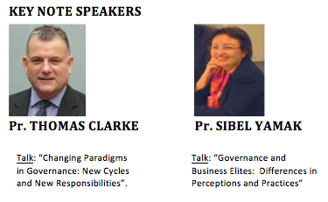

**IMPORTANT DATES**

**Workshop (09-10 June 2014)**

Deadline for 2 pages Proposals submission: 28 February 2014

Notification of acceptance as of 28 March 2014

Early bird/authors registration 25 April 2014

For more information please visit: [**http://tbs-education.es/es/profesorado-investigacion/workshop-governance**](http://tbs-education.es/es/profesorado-investigacion/workshop-governance)

**ORGANIZING COMMITTEE**

Wafa Khlif, Toulouse Business School Barcelona, Spain ([w.khlif@tbs-education.es](mailto:w.khlif@tbs-education.es))

Coral Ingley, AUT University, Auckland, New Zealand ([coral.ingley@aut.ac.nz](mailto:coral.ingley@aut.ac.nz))

Lotfi Karoui, Ecole de Management- Normandie, France ([lkaroui@em-normandie.fr](mailto:lkaroui@em-normandie.fr))

|  |  |
| --- | --- |
|  |  |