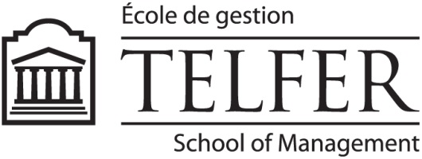

CALL FOR PAPERS

2015 ALTERNATIVE ACCOUNTS CONFERENCE
Telfer School of Management, University of Ottawa - Desmarais Building
Friday, April 17 and Saturday, April 18, 2015

Since the beginning of the 1980s, the field of interpretive and critical accounting research has become increasingly diverse. A range of research epistemologies and methodologies have developed to provide new insights into accounting, auditing, governance, public policy and risk management. Sometimes designated as “alternative” or “interdisciplinary”, this eclectic and diverse body of research is characterized by the overarching objectives of developing better understandings of accounting from organizational and sociological angles, and of encouraging better accounting and accountability practices.

The Alternative Accounts Conference brings together accounting faculty and doctoral students from North America and beyond who are interested in alternative accounting research. The Conference especially aims to increase accounting researchers’ awareness of the diverse areas of research belonging to the “alternative” paradigm of accounting research, and to provide a forum to discuss these studies from a variety of viewpoints – in a constructive environment. This conference rotates between Alberta, Ontario and Québec.

The 2015 Conference will be held in Ottawa on Friday, April 17th and Saturday, April 18th at the Telfer School of Management of the University of Ottawa. We are interested in receiving critical and interpretive papers at a relatively advanced stage of completion or already submitted to journals but not yet accepted for publication. The deadline for submission of papers is February 1, 2015. Papers should be submitted through the Conference website (www.telfer.uOttawa.ca/AAC2015). Following a double blind review process, selected authors will be notified by February 28, 2015 and will need to provide the complete version of their paper by March 25, 2015. The conference agenda, as well as full-paper submissions, will be posted on the conference website.

The conference is sponsored by the Telfer School of Management of the University of Ottawa and the CPA Canada Accounting and Governance Research Center at the University of Ottawa.
The Conference fee is $250. For more information, contact Sylvain Durocher durocher@telfer.uOttawa.ca) or Darlene Himick (himick@telfer.uOttawa.ca).
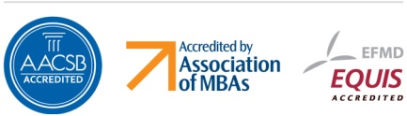

APPENDIX
Emerging Scholars Colloquium

The Emerging Scholars Colloquium is a one-day event (Thursday, April 16, 2015) which precedes the main conference. In particular, the Colloquium aims to provide doctoral students and emerging researchers with the opportunity to discuss their work with other doctoral students and established scholars in the field.

The Colloquium is organized by Sylvain Durocher and Darlene Himick from the Telfer School of Management at the University of Ottawa. Two other scholars (to be identified) will join them to listen to students’ presentations and provide them with live feedback. The time allowed for each participant will depend on the number of participants.

Participation
Doctoral students and emerging researchers should send a CV and a 3-page document in which they outline their doctoral research project. Documents should be sent to Sylvain Durocher (durocher@telfer.uottawa.ca) or Darlene Himick (himick@telfer.uottawa.ca) by February 1, 2015. Notification of acceptance will be given by February 28, 2015.

It should be noted that preference will be given to doctoral students who are beyond the first year of their PhD studies. The number of participants will be limited to 12.

Doctoral students and emerging researchers are allowed to submit papers to the main conference. However, papers submitted to the main conference need to be different from papers submitted to the Colloquium.

Fees
There will be no fees (Colloquium and main conference) for doctoral students who are selected as participants to the Emerging Scholars Colloquium.

